PHP PDF FILE

FLOWDIARY ACADEMY

**Date**: Based on Time Table

**Time**: Based on Time Table

**Facilitator**: MM LEFAGANA

Contents

Week One (1) 2

Week Two (2) 4

Week Three (3) 4

# Week One (1)

* Welcome to Flowdiary Academy
* Welcome to the Course
* Introduction to PHP?
* What is PHP?
* PHP is an acronym for "PHP: Hypertext Pre-processor"
* PHP is a widely-used, open-source scripting language
* PHP scripts are executed on the server
* PHP is free to download and use
* **PHP is an amazing and popular language!**
* It is powerful enough to be at the core of the biggest blogging system on the web (WordPress)!  
  It is deep enough to run large social networks!  
  It is also easy enough to be a beginner's first server-side language!
* What is PHP file?
* PHP files can contain text, HTML, CSS, JavaScript, and PHP code
* PHP code is executed on the server, and the result is returned to the browser as plain HTML
* PHP files have extension ".php"
* What Can PHP Do?
* PHP can generate dynamic page content
* PHP can create, open, read, write, delete, and close files on the server
* PHP can collect form data
* PHP can send and receive cookies
* PHP can add, delete, modify data in your database
* PHP can be used to control user-access
* PHP can encrypt data
* Why PHP?
* PHP runs on various platforms (Windows, Linux, Unix, Mac OS X, etc.)
* PHP is compatible with almost all servers used today (Apache, IIS, etc.)
* PHP supports a wide range of databases
* PHP is free. Download it from the official PHP resource: [www.php.net](http://www.php.net/)
* PHP is easy to learn and runs efficiently on the server side
* What u need before installing a PHP?

Before installing PHP, you must have the following install on your PC

* Web Browser
* Xampp/wamp server
* Installation of PHP (XAMPP)
  + [Download Xampp](https://www.apachefriends.org/download.html)

Click on the above link to download the xampp from their website the page may look like this. Choose your platform and version scroll down if u are not on windows (MacOS Linux)

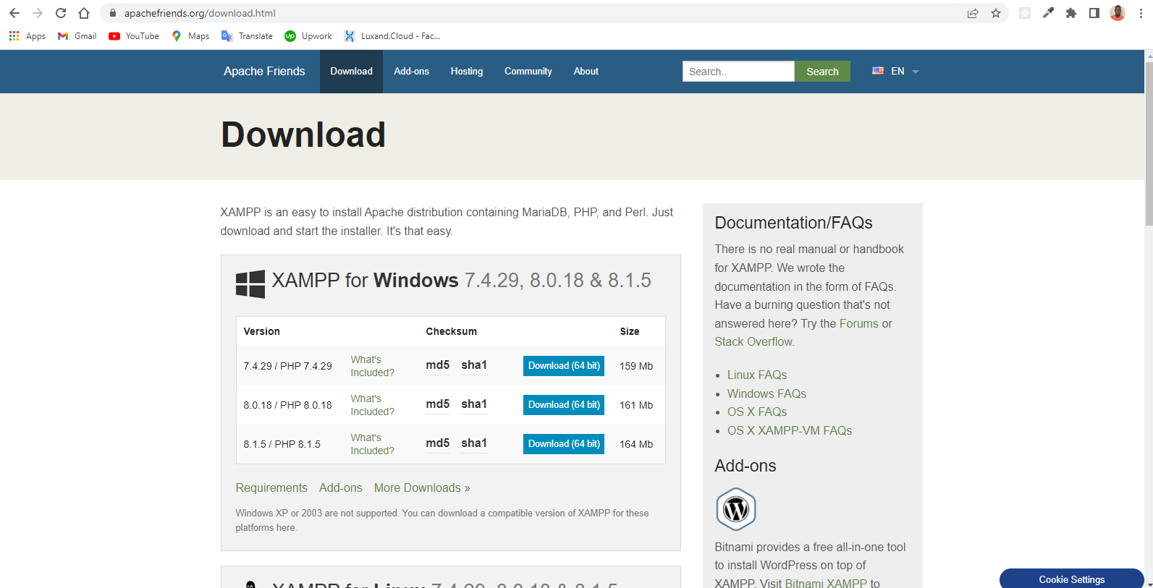

* Creating your first PHP file
* Refer to the vid attach to this file
* That’s All for todays Lecture thank u All

# Week Two (2)

* Basic PHP Syntax
* PHP Case Sensitivity
* PHP Variable
* PHP Data Type
* PHP Math Function
* PHP Constant
* PHP Operator

# Week Three (3)

* PHP Conditional Statement
* PHP Loops
* PHP Function
* PHP Array
* Bonus Section